Assignment 03
Artificial Intelligence – AI 2101

Announced Date: April 20, 2026 | Due Date: May 04, 2026 | Total Marks = 20
Instructor Name: Hamid Ashfaq |  | Marks Obtained =

[CLO2, C3]
Q1. Apply Prim’s algorithm manually on paper add picture and also write its code with output. 5 marks
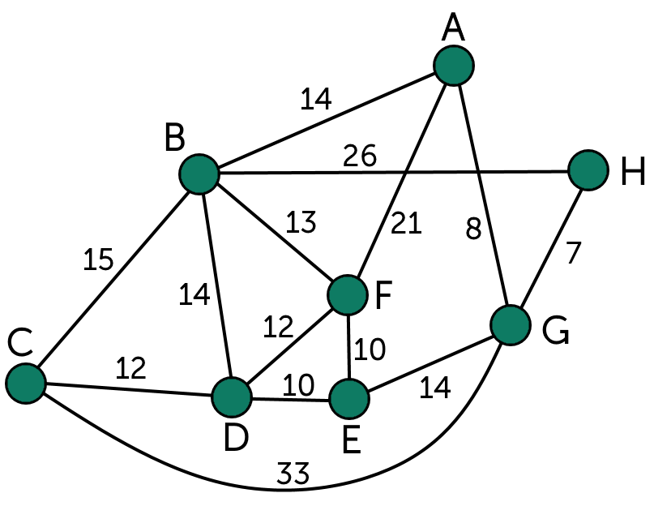
Q2. Apply Kruskal’s algorithm manually on paper add picture and also write its code with output.5 marks
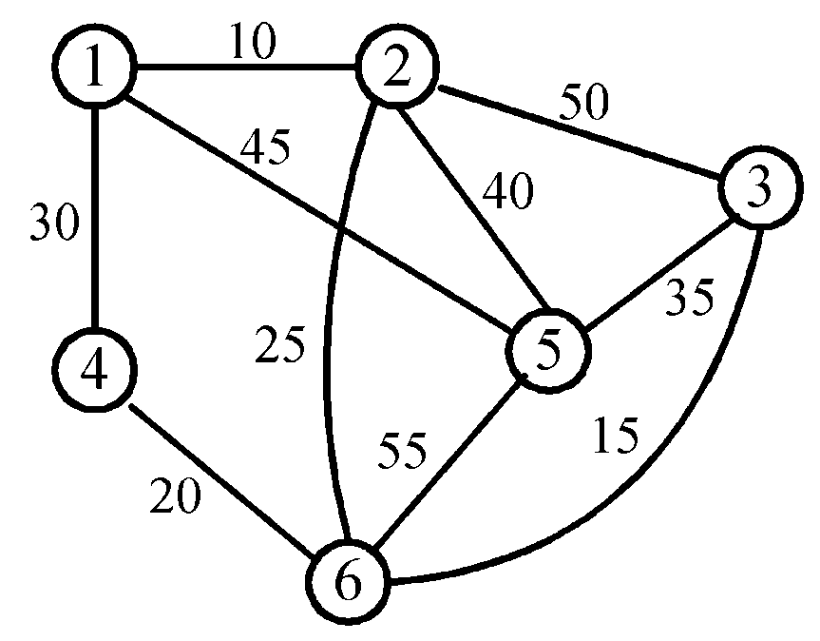
Q3. Solving the 8-Queens Puzzle via Evolutionary Computing. 10 marks
Objective:
To design and implement a Genetic Algorithm (GA) that finds a non-attacking configuration for 8 queens on an 8x8 chessboard.
Problem Description:
The 8-Queens problem requires placing eight chess queens on an 8x8 board such that no two queens threaten each other. This means no two queens can share the same row, column, or diagonal.
Task Requirements:
- Representation: Define a chromosome structure (e.g., a 1D array of 8 integers) to represent the board state.
- Fitness Function: Develop a function that calculates the "fitness" of a state based on the number of non-attacking pairs of queens (Maximum score: 28).
- Genetic Operators:
    - Implement Selection (e.g., Roulette Wheel or Tournament selection).
    - Implement Crossover (e.g., Single-point or Uniform crossover).
    - Implement Mutation (e.g., Randomly swapping a queen's position).
- Analysis: Run the algorithm 10 times and report the average number of generations required to find a solution.
Deliverables:
- Code and its output screenshot.
Note: Submit a single pdf document with images of manually solved and code with output.

